Image Steganography Using Triple DES

INDEX

- ABSTRACT
- TRIPLE DES
- WORKING
- FLOW CHART
- OUTPUT
- ADVANTAGES
- DISADVANTAGES
- CONCLUSION
- REFERENCE

Abstract
In today’s world almost all digital services like internet communication, medical and military imaging systems, multimedia system needs a high level security. There is a need for security level in order to safely store and transmit digital images containing critical information. This is because of the faster growth multimedia technology, internet and cell phones. Therefore there is a need for image encryption techniques in order to hide images from such attacks. In this system we use Triple DES (Data Encryption Standard) in order to hide image. Such Encryption technique helps to avoid intrusion attacks.

Triple-DES :
Triple-DES is a process in which we encrypt an image, text or video using 56 bit two keys or 128 bit keys. This kind of process may be secure but still has its flaws. To overcome this flaw we encrypted out file with three 56 bit keys instead of two keys. Hence making it more secure. In the previous referred case study there was only two keys were used for encryption process. Triple-DES process follows EDE model as shown in figure below. EDE model states that every file or text must be encrypted twice and decrypted once in a sequential order to perform encryption process. First it encrypts using one secret key and then decrypts using a different secret key finally encrypts using same encrypt key. So the flaw was if the hacker got to know one secret key it’s very easy to apply brute force attack. Hence to overcome this flaw we are using three different keys for every EDE process. EDE uses 192 bit keys out of which only 168 bits are used for encryption process. Still a very strong algorithm even though we don’t use the last eight bits. Which makes it more secure over a network.
Triple-Des pseudo code:
Encryption [EDE]:
Input: image_bits, key_64bit1, key_64bit2, key_64bit3
Logic:
Import sys
For img in image_bits:
For each 64bits in img:
64bitimglst.append (64bits) /
/create 16 sub keys
//for three separate keys
For I in range 1 to 3
For each 64key_bit(n) in range of 16:
56bit_16key1 = Permute (key_64bit1)
56bit_16key2 = Permute (key_64bit2)
56bit_16key3 = Permute (key_64bit3)
//rearranges the bits (shift cipher)
For l1 in 64bitimglst:
64bitimglst=Initial_permutation (l1)
//16 iterations for 1<=n<=16(n=index number of keys)
For l1 in 64bitimglst:
For I, j, k in 56bit_16key1, 56bit_16key2, 56bit_16key3:
Cipherimg64bits=Encrypt(64bitimglst, i)
Cipherimg64bits=Decrpyt(64bitimglst,j)
Cipherimg64bits=Encrypt(64bitimglst, k)
Cipherimg64bits=Inverse(Finalpermutation (Cipherimg64bits))
For cimg in Cipherimg64bits:
Cipherimg= Cipherimg+cimg
Output:
[Encrypted_image]= Cipherimg
For cimg in Cipherimg64bits:
Cipherimg= Cipherimg+cimg
Output:
[Encrypted_image]= Cipherimg

Triple-Des pseudo code:
Decryption: [DED]
Input: Cipherimg _bits, key_64bit1, key_64bit2, key_64bit3
Logic:
Import sys
For cimg in Cipherimg _bits:
For each 64bits in cimg:
64bitcimglst.append (64bits)
For I in range 1 to 3:
For each 64key_bits in range of 16:
56bit_16key1 = Permute (key_64bits)
56bit_16key2 = Permute (key_64bits)
56bit_16key3 = Permute (key_64bits)
//rearranges the bits(shift cipher)
For l1 in 64bitimglst:
64cbitimglst=Initial_permutation(l1)
//16 iterations for 1<=n<=16(n=index number of keys)
For l1 in 64cbitimglst:
For I, j, k in 56bit_16key1, 56bit_16key2, 56bit_16key3:
Cipherimg64bits=Encrypt (64bitimglst,j)
Cipherimg64bits=Decrypt (64bitimglst, k)
//finalpermuation
img64bits =Inverse (Finalpermutation (img64bits))
For img in img64bits:
Imgr = imgr + img
Output:
[Decrypted image]=imgr

Working
Triple DES uses total three DES Keys say K₁, K₂ and K₃, each of 56 bits. This does not include parity bits. The encryption algorithm is:
CipherText= E_{K3}(D_{K2}(E_{K1}(plaintext)))
I.e., DES encrypt with K₁, DES decrypt with K₂, then DES encrypt with K₃.
Decryption is the reverse:
Plain Text = D_{K1}(E_{K2}(D_{K3}(CipherText)))
I.e., decrypt with K₃, encrypt with K₂, then decrypt with K₁.

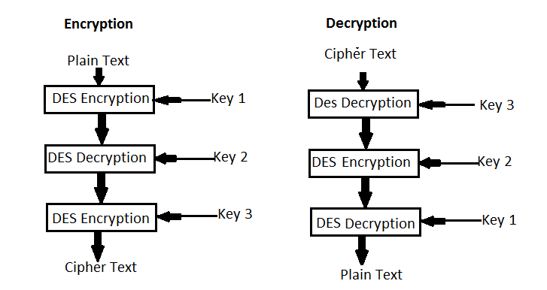

OUTPUT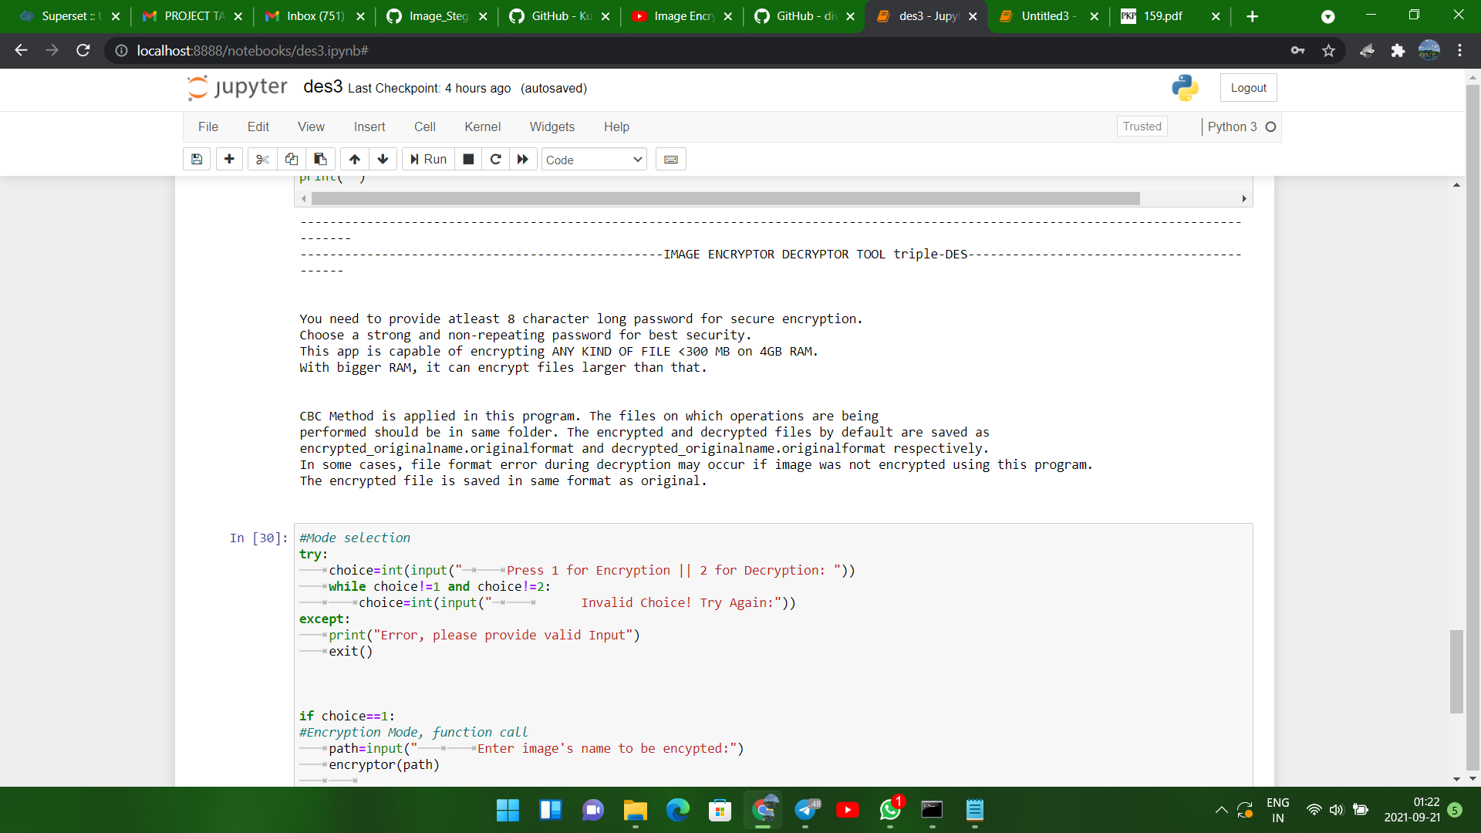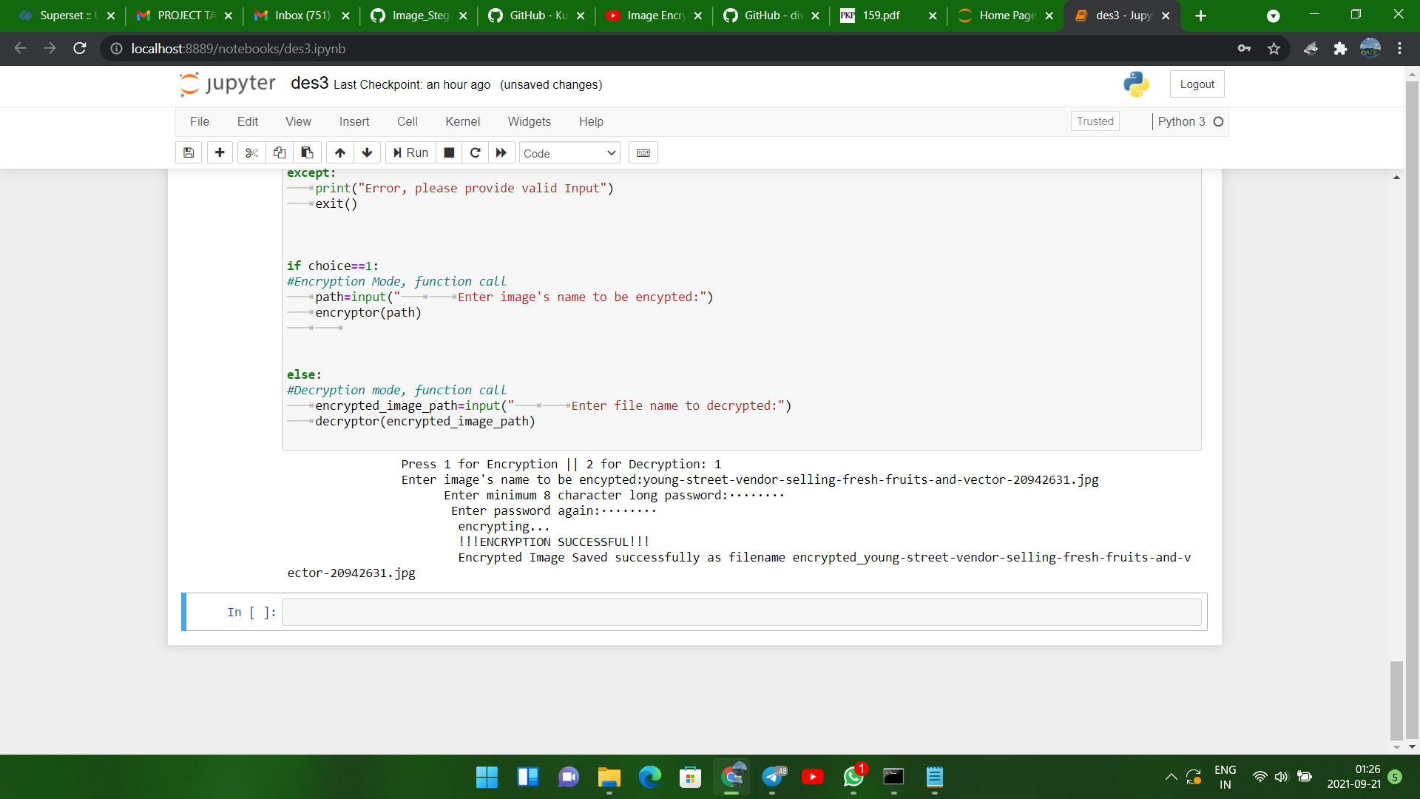
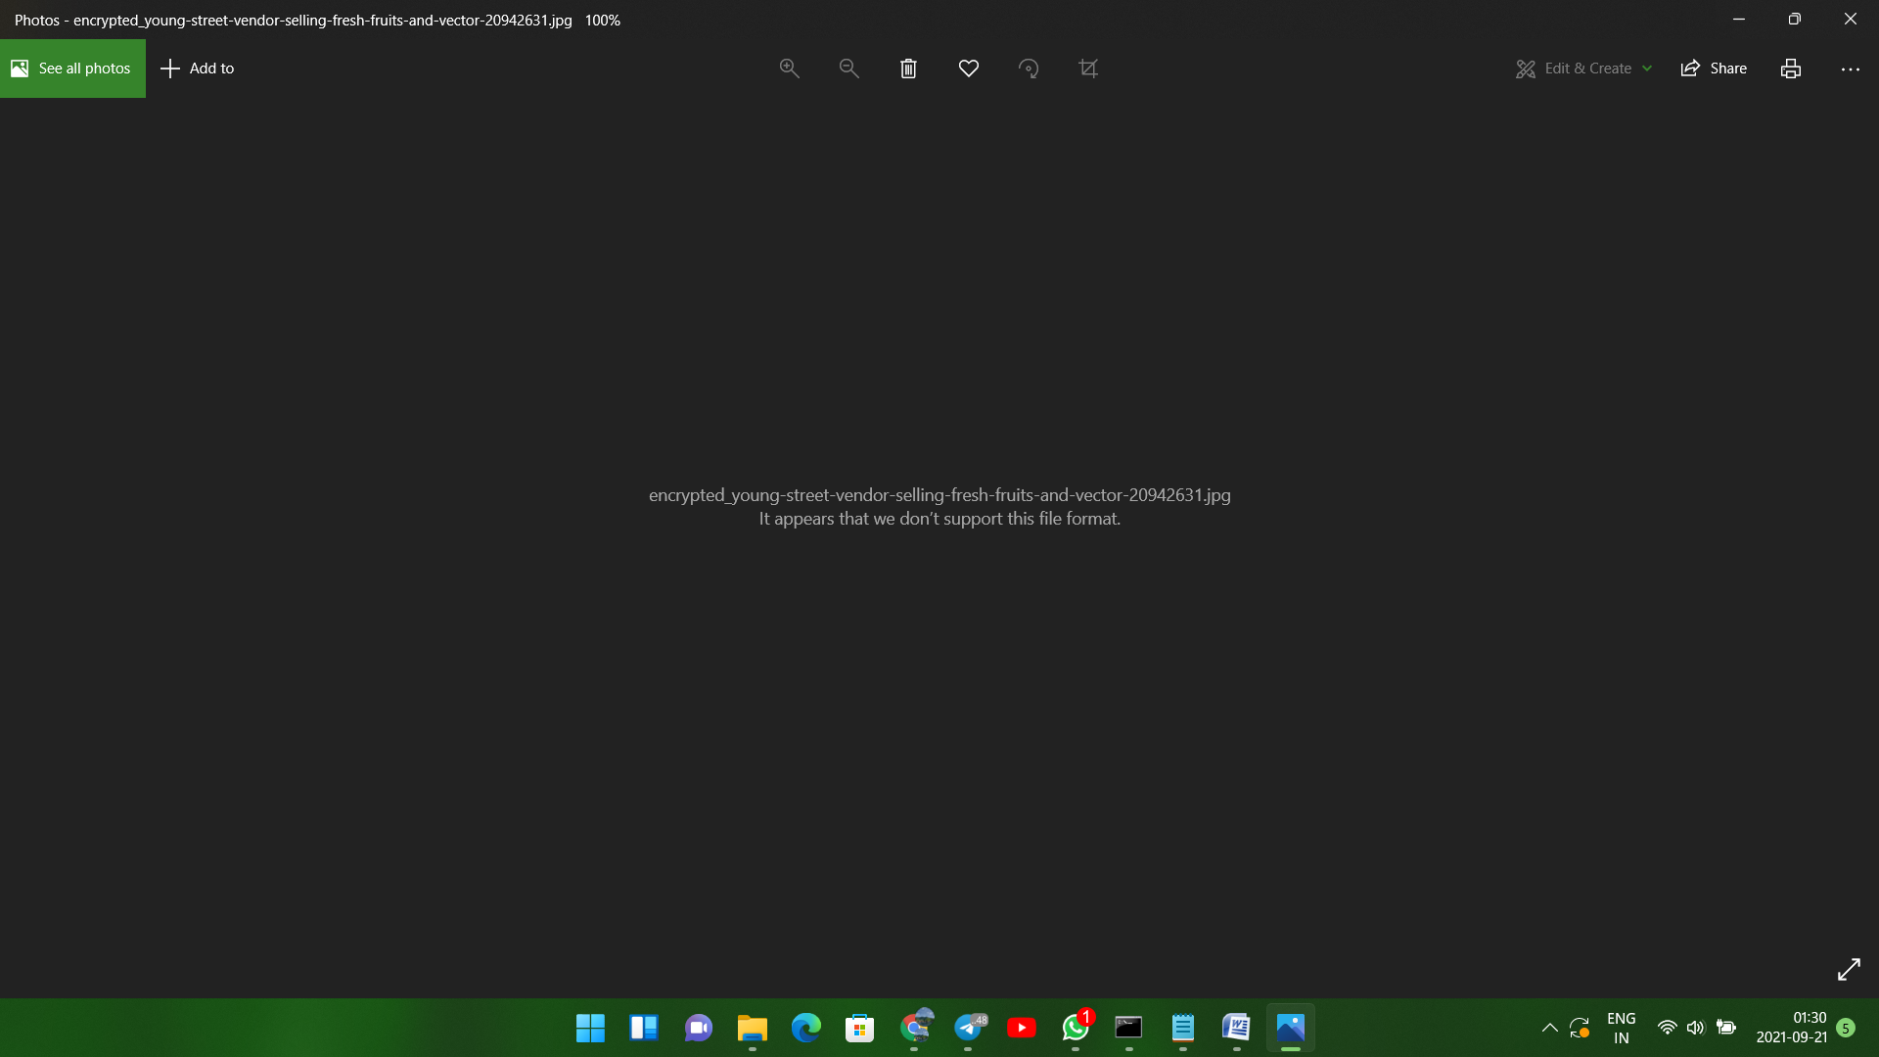
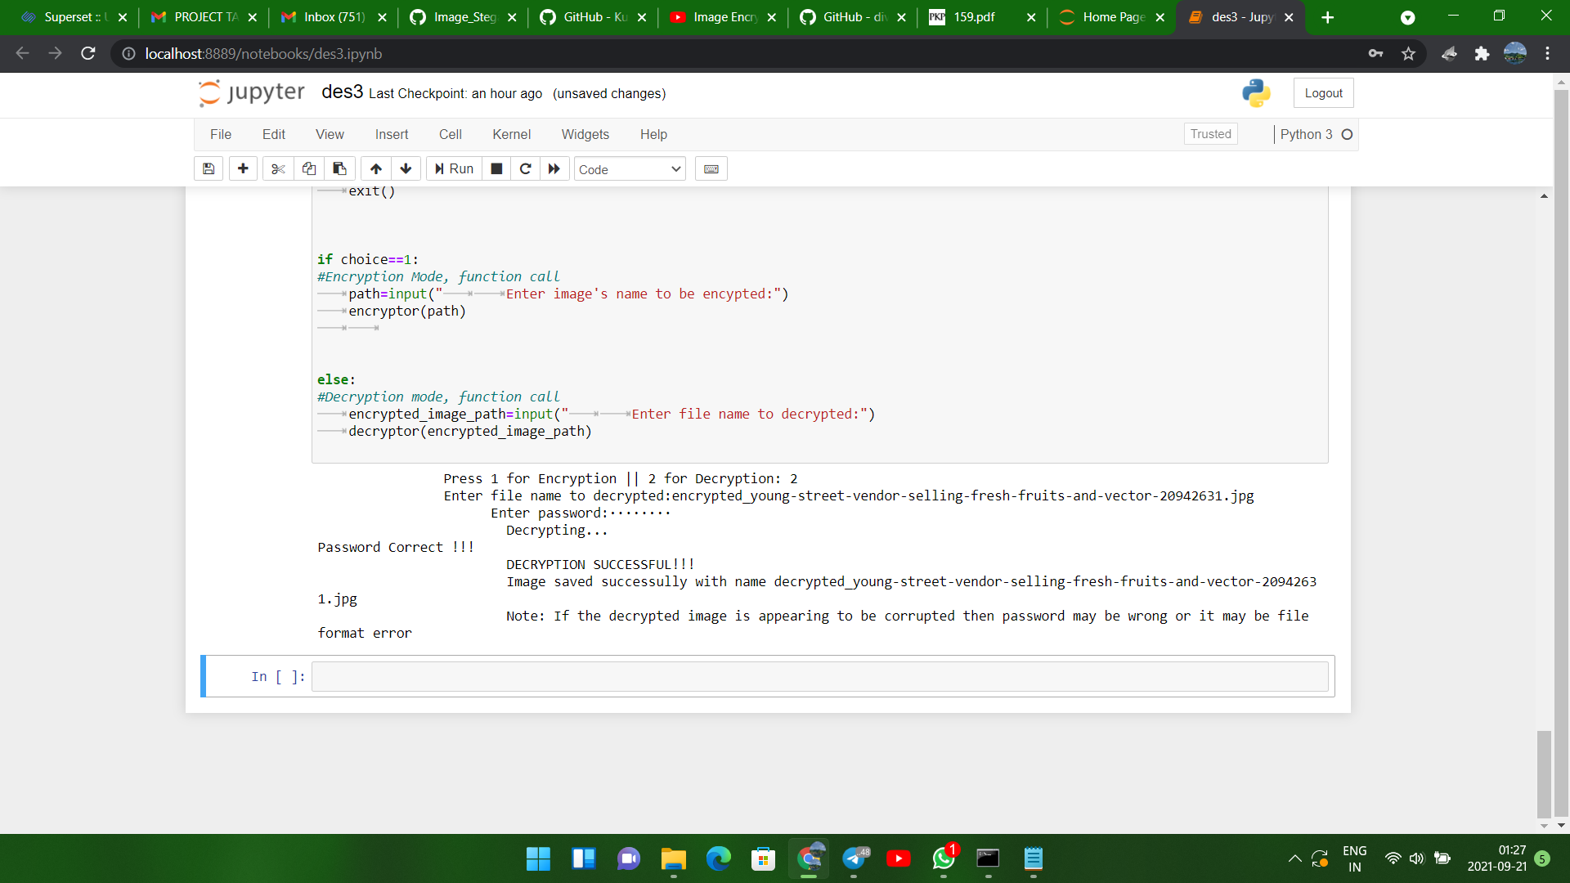



Advantages
- The image can only be viewed by the receiver as the image is encrypted using Triple DES and the key is only known to the sender and receiver.
- Since the image is encrypted using Triple DES, it is more secure than the DES.
- Since the key is entered by the sender and receiver, it makes the encryption and decryption more secure.

Disadvantages
- The file size to be transmitted becomes large since it contains encrypted data.
- Since the file size is huge it can be suspected to contain some critical information.

Future scope
FUTURE WORK In the future it’s possible to view the images that are encrypted well such that nobody could crack it or decrypt it that easily because of the above research paper.
Conclusion
The above results and discussions proves that Triple-Des provides a better quality encryption process where as we observed that des provides better performance in encryption and decryption process. This becomes a big flaw when we are running multiple process over a network. The time will be increased for Triple-DES process the future work would also concern the better assurance of quality and performance for all types of multimedia data. The latter work would involve encrypting video and audio files, with a cross platform of different algorithms.

Reference

- http://ieeexplore.ieee.org/xpl/articleDetails.jsp?arnumber=5071626&queryText=image%20thriple%20des&newsearch=true

- http://ieeexplore.ieee.org/xpl/articleDetails.jsp?arnumber=6187857&queryText=image%20thriple%20des&newsearch=true

